Starry Night

Using Python, Randomness & Turtle

By Sunil Dangal

## Introduction

In this Starry Night project, I am going to create Starry Night effect by creating stars in a black background. To define the criteria for our project, we have objectives which are:

1. **Creating stars randomness**

I am going to use black background to give a feel of night sky.

1. **Using Randomness**

I am going to use random library to create different size and position of stars.

1. **Using for loop**

I am going to use for loop to generate lot of stars.

## Design

Now, this is a phase we find out what our design requirements look like. We are going to have Diagram, Flowchart, and pseudocode for the visual part.

**Diagram**

Below is the diagram with dark background with lot of stars.

**Flowchart**

Below, is the flowchart for this project.

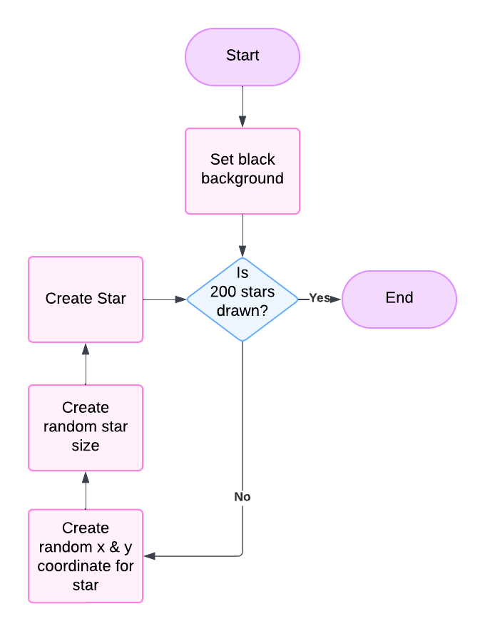

**Pseudocode**

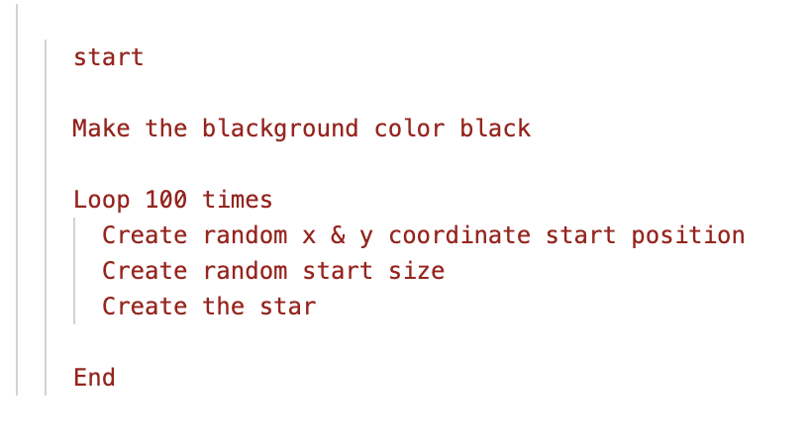

## Implementation

Check the code in *starry_night.py* and *final_starry_Night_project.py* file to see the code implementation and *final_starry_Night_project.py* for final project completion.

## Having Bug?

If we encounter bug like “non integer arg 1 for randrange ()” read this otherwise just ignore. So, it basically means, we are not giving an integer for randrange () function so randrange () function is not called. randrange () requires two integers, minimum and maximum. And when there is error, it is because, we are giving a floating number when width is an odd number and divided by 2. To fix that, we must round that number to the nearest integer using the round function.

*x = randrange(round(-width/2), round(width/2))*

*y = randrange(round(-height/2), round(height/2))*

Now the parameters will be rounded by giving nearest integer making the function work.

## Feature

So, we are going to have moon as well and we are going to experiment different colors to make it dusk and dawn. And finally, we are going to increase the stars. Check *final_starry_Night_project.py* for feature implementation.

## Evaluate

So, we have created black background, and generated stars using dot making stars feel in a cosmic sky. We have randomized the star size and position to feel like twinkling start or appearing star. And at last, we have use for loop to repeat the process for 100 times to have more stars and the project is successful.